| Availability of sanitary Infrastructure at the Household level(n=791) | | |
| --- | --- | --- |
| Sanitary infrastructure accessed | Available | Not available |
| Bath shelter/ bathroom | 744 (94.1%) | 47 (5.9%) |
| Designated kitchen area | 551 (69.7%) | 240 (30.3%) |
| Household handwashing facility | 240 (30.3%) | 551 (69.7%) |
| Soap or detergent available | 171 (21.6%) | 620 (78.4%) |
| Solid waste disposal | 473 (59.8%) | 318 (40.2%) |
| Toilet facility available | 742 (93.8%) | 49 (6.2%) |

Condition of Sanitary Infrastructures at the time of the study visit.

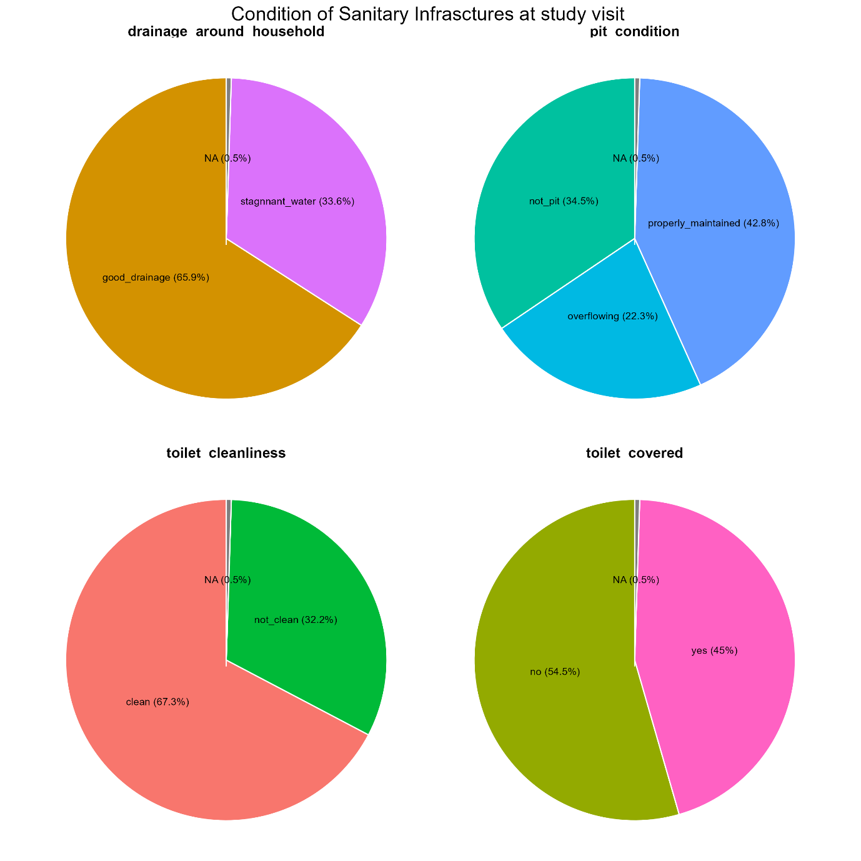

Overall Sanitary Status

To find the overall Sanitary WASH status at the household level, the following variables were added: Bath shelter/ bathroom Designated kitchen area, Household handwashing facility, Soap or detergent available, Toilet facility available, Solid waste disposal, Drainage around the household, Pit Condition, Toilet Clean and Toilet covered. The cut-off point was a median. Those equal to and above the median were classified as adequate, and those below the median were classified as inadequate.

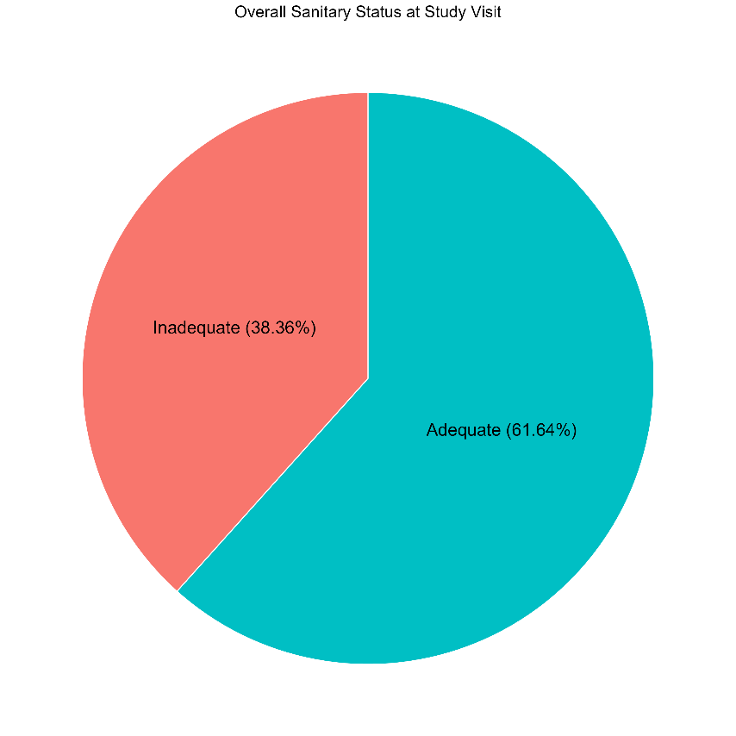

The difference of sanitary Status among the demographic

| **Characteristic** | **Adequate**  N = 4901 | **95% CI**2 | **Inadequate**  N = 3051 | **95% CI**2 | **p-value**3 |
| --- | --- | --- | --- | --- | --- |
| Sex |  |  |  |  | 0.6 |
| Female | 377 (77%) | 73%, 81% | 230 (75%) | 70%, 80% |  |
| Male | 113 (23%) | 19%, 27% | 75 (25%) | 20%, 30% |  |
| Age group |  |  |  |  | 0.5 |
| >50 | 113 (23%) | 19%, 27% | 61 (20%) | 16%, 25% |  |
| 18-30 | 178 (36%) | 32%, 41% | 111 (36%) | 31%, 42% |  |
| 31-50 | 199 (41%) | 36%, 45% | 133 (44%) | 38%, 49% |  |
| Level education |  |  |  |  | >0.9 |
| None | 65 (13%) | 10%, 17% | 43 (14%) | 10%, 19% |  |
| Primary | 306 (62%) | 58%, 67% | 193 (63%) | 58%, 69% |  |
| Secondary | 108 (22%) | 19%, 26% | 62 (20%) | 16%, 25% |  |
| Tertiary | 11 (2.2%) | 1.2%, 4.1% | 7 (2.3%) | 1.0%, 4.9% |  |
| Religion |  |  |  |  | 0.073 |
| Christianity | 377 (77%) | 73%, 81% | 215 (70%) | 65%, 75% |  |
| Muslim | 102 (21%) | 17%, 25% | 77 (25%) | 21%, 31% |  |
| Others religion | 11 (2.2%) | 1.2%, 4.1% | 13 (4.3%) | 2.4%, 7.4% |  |
| Marital status |  |  |  |  | 0.2 |
| Divorced | 31 (6.3%) | 4.4%, 9.0% | 30 (9.8%) | 6.8%, 14% |  |
| Married | 365 (74%) | 70%, 78% | 201 (66%) | 60%, 71% |  |
| Separated | 17 (3.5%) | 2.1%, 5.6% | 12 (3.9%) | 2.1%, 7.0% |  |
| Single | 38 (7.8%) | 5.6%, 11% | 30 (9.8%) | 6.8%, 14% |  |
| Widow | 30 (6.1%) | 4.2%, 8.7% | 24 (7.9%) | 5.2%, 12% |  |
| Widower | 9 (1.8%) | 0.90%, 3.6% | 8 (2.6%) | 1.2%, 5.3% |  |
| Occupation |  |  |  |  |  |
| Farmer | 235 (48%) | 43%, 52% | 138 (45%) | 40%, 51% |  |
| Fisherman | 2 (0.4%) | 0.07%, 1.6% | 2 (0.7%) | 0.11%, 2.6% |  |
| fish Sellar | 2 (0.4%) | 0.07%, 1.6% | 1 (0.3%) | 0.02%, 2.1% |  |
| Housewife | 74 (15%) | 12%, 19% | 42 (14%) | 10%, 18% |  |
| Other business | 109 (22%) | 19%, 26% | 80 (26%) | 21%, 32% |  |
| Other occupation | 41 (8.4%) | 6.1%, 11% | 33 (11%) | 7.7%, 15% |  |
| professional worker | 14 (2.9%) | 1.6%, 4.9% | 5 (1.6%) | 0.61%, 4.0% |  |
| Retired | 6 (1.2%) | 0.50%, 2.8% | 3 (1.0%) | 0.25%, 3.1% |  |
| Student | 7 (1.4%) | 0.63%, 3.1% | 1 (0.3%) | 0.02%, 2.1% |  |
| Ethnicity |  |  |  |  |  |
| Chewa | 249 (51%) | 46%, 55% | 143 (47%) | 41%, 53% |  |
| Lomwe | 39 (8.0%) | 5.8%, 11% | 26 (8.5%) | 5.7%, 12% |  |
| Ngonde | 2 (0.4%) | 0.07%, 1.6% | 2 (0.7%) | 0.11%, 2.6% |  |
| Ngoni | 61 (12%) | 9.7%, 16% | 40 (13%) | 9.6%, 18% |  |
| Nyanja | 8 (1.6%) | 0.76%, 3.3% | 6 (2.0%) | 0.80%, 4.4% |  |
| Other enthni | 8 (1.6%) | 0.76%, 3.3% | 1 (0.3%) | 0.02%, 2.1% |  |
| Sena | 2 (0.4%) | 0.07%, 1.6% | 1 (0.3%) | 0.02%, 2.1% |  |
| Tonga | 19 (3.9%) | 2.4%, 6.1% | 5 (1.6%) | 0.61%, 4.0% |  |
| Tumbuka | 9 (1.8%) | 0.90%, 3.6% | 2 (0.7%) | 0.11%, 2.6% |  |
| Yao | 93 (19%) | 16%, 23% | 79 (26%) | 21%, 31% |  |

Association of Sanitary Status and places of residence

| **Characteristic** | **Adequate**  N = 4901 | **95% CI**2 | **Inadequate**  N = 3051 | **95% CI**2 | **p-value**3 |
| --- | --- | --- | --- | --- | --- |
| District |  |  |  |  | 0.015 |
| Balaka | 15 (3.1%) | 1.8%, 5.1% | 19 (6.2%) | 3.9%, 9.7% |  |
| Blantyre | 69 (14%) | 11%, 18% | 61 (20%) | 16%, 25% |  |
| Dedza | 62 (13%) | 9.9%, 16% | 43 (14%) | 10%, 19% |  |
| Lilongwe | 202 (41%) | 37%, 46% | 98 (32%) | 27%, 38% |  |
| Mangochi | 77 (16%) | 13%, 19% | 52 (17%) | 13%, 22% |  |
| Nkhatabay | 27 (5.5%) | 3.7%, 8.0% | 9 (3.0%) | 1.4%, 5.7% |  |
| Salima | 38 (7.8%) | 5.6%, 11% | 23 (7.5%) | 4.9%, 11% |  |
| Residence |  |  |  |  | 0.6 |
| In land | 333 (68%) | 64%, 72% | 202 (66%) | 61%, 71% |  |
| Lake shores | 157 (32%) | 28%, 36% | 103 (34%) | 29%, 39% |  |

Cholera Site Site

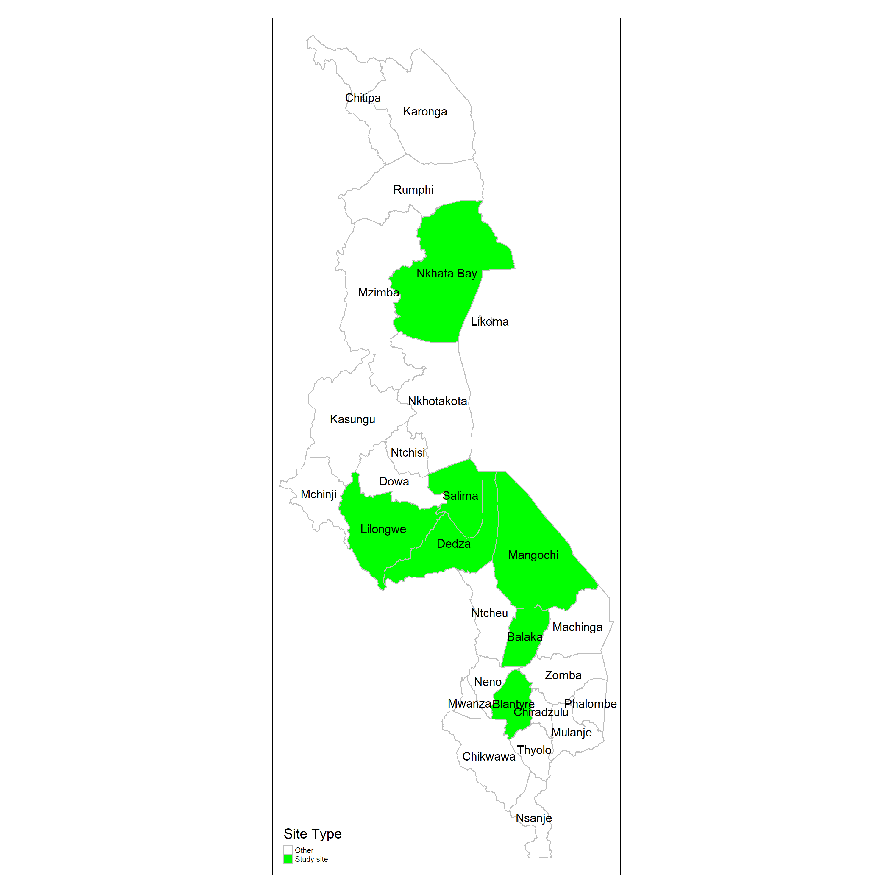

Spatial Distribution of Sanitary Infrastructure in selected PAMI in Malawi

